**Develop the Python Script**

**(Develop a Python script)**

|  |  |
| --- | --- |
| Date | 04 November 2022 |
| Team ID | PNT2022TMID25653 |
| Project Name | Industry-specific intelligent fire management system |
| Maximum Marks | 4 Marks |

**Industry-specific intelligent fire management system**

Create a code snippet using python to

1. Extract weather data from OpenWeatherMap using APIs
2. Send the extracted data to the cloud
3. Receive data from the cloud and view it in the python compiler

**PRAGATHA P**

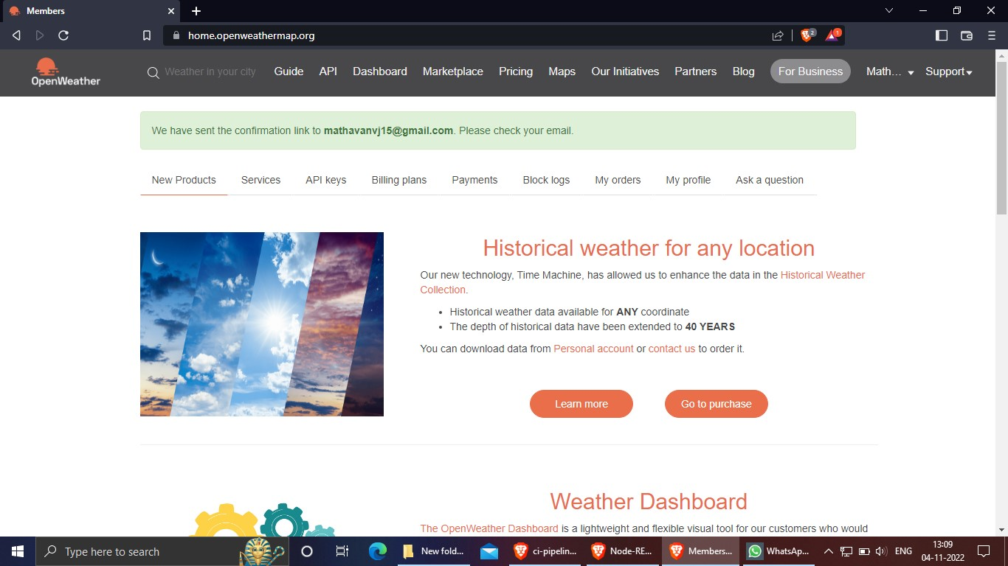

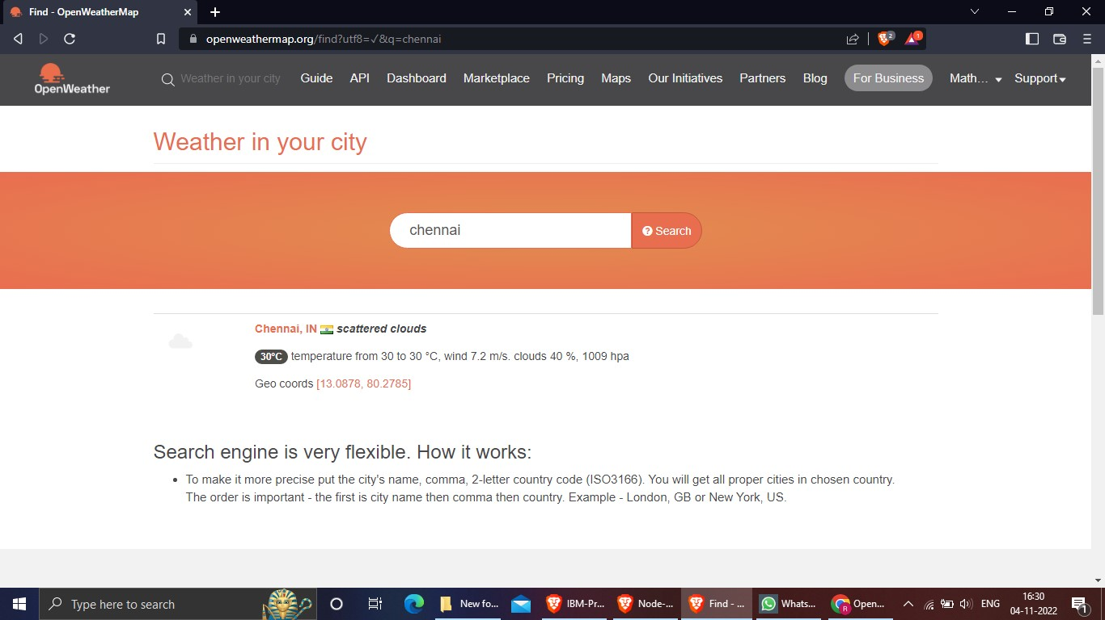

**RAGAVI S**

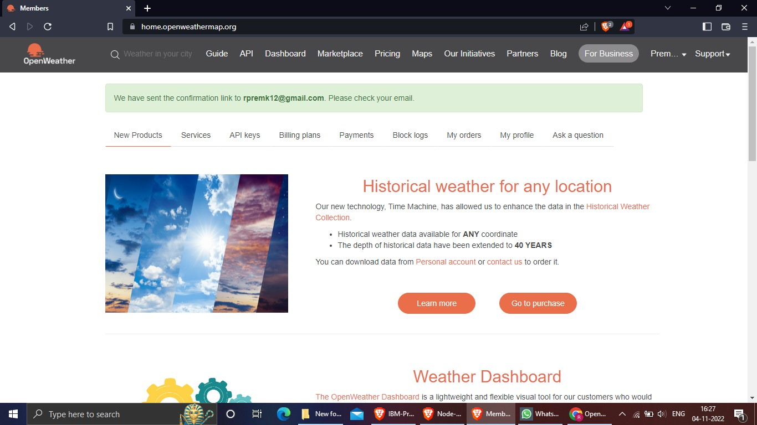

**SASIREKA G**

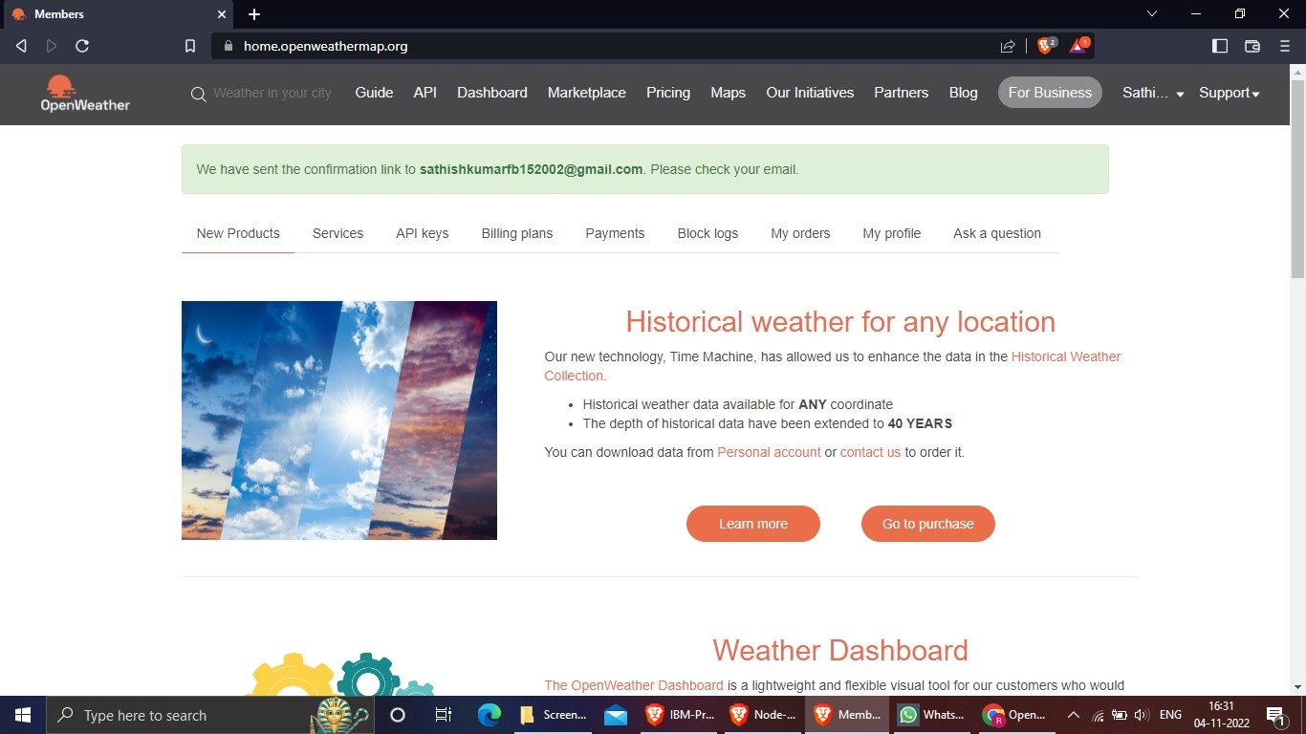

**SHANMUGAPRIYA V**

